ACTIVITY – Surface Area to Volume Ratio

Name: ___________________ Date: ____________________ Block: ____________

Think of a cell as a cube. We are going to look at how the size of the cell affects its efficiency. In this case, efficiency means how good the cell is at absorbing nutrients and eliminating wastes through its cell membrane.
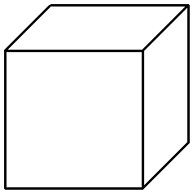
Surface Area (SA) of a cube = 6 x side length x side length

Volume = side length x side length x side length

Cube | Side length | Surface Area | Volume | SA:Volume | Efficiency
 | (cm) | (cm²) | (cm³) | Ratio | of Cell
1 | 1 | 6 x 1 x 1 = 6 | 1 x 1 x 1 = 1 | 6:1 | 6 ÷ 1 = 6
2 | 2
3 | 3
4 | 4

Questions:
- Which cube had a larger surface area to volume ratio, cube 1 or cube 4?

- Which cube has the greatest surface area to volume ratio (the best efficiency)?

- What type of cell, smaller or larger, would have a higher surface area to volume ratio and therefore better efficiency?

- Nine small cells have the same volume (take up the same amount of space) as a certain large cell. Which has more cell membrane for nutrients and wastes to pass: the one large cell or the nine smaller cells?

