2.2 Osmosis Date: 04.02.2012

What is osmosis?
- Osmosis is the movement of water molecules from a solution of higher water potential to a solution of lower water potential, through a partially permeable membrane.
- Water moves DOWN the water potential gradient.
What is water potential and how is it related to osmosis?
- Water potential is a measure of tendency of water to move from one place to another.
- The term ‘water potential’ is always used/connected to OSMOSIS.
- A dilute solution contains more water molecules per unit volume than a concentrated solution – therefore, has a HIGHER concentration than a concentrated solution.
Q. Which one has a higher water potential? Ans: Beaker A – More water, less sucrose molecules.
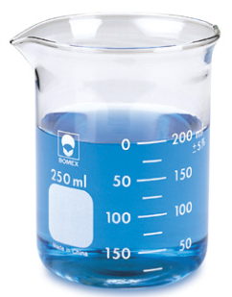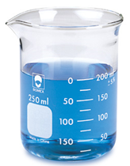
Containing:
10% sucrose solution
Beaker B
Containing:
5% Sucrose solution
Beaker A
- When a partially permeable membrane separates two solutions of different water potentials, a water potentials gradient is established.
- When a water potential gradient is established, the process of osmosis will occur.

For example:

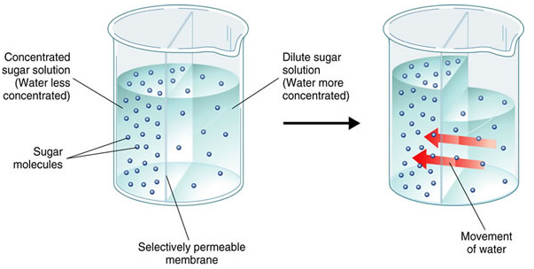

Remember:
The cell wall of plants = permeable! , While the cell membrane is = partially permeable!
How does osmosis affect living organisms?
- A plant cell behaves differently from an animal cell when placed in solutions with differing water potentials, due to the presence of the cell wall in plant cells.
Q. What happens to a plant cell in a solution with high/low/equal water potential?
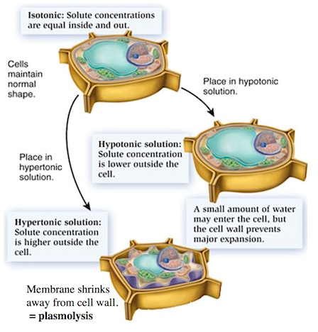
Isotonic solution | Hypertonic solution | Hypotonic solution
- The solute concentrations are equal on both sides – equal water potential.  - Therefore, normal movement of water inside and out.  - Cell maintains its shape. | - The solute concentrations are higher outside compared to the cell sap – low water potential outside.  - Water molecules moves outside by osmosis.  - The cytoplasm shrinks away from cell wall - Cell plasmolysis. | - The solute concentration is lower outside the cell – high water potential outside.  - Water molecules enter by osmosis.  - Cell enlarges and becomes turgid.  - Cell wall prevents cell from bursting.
- The turgidity of the cell with water is called turgor, and the pressure exerted by the water on the cell wall is the turgor pressure.
Q. What happens to an animal cell in a solution with high/low/equal water potential?
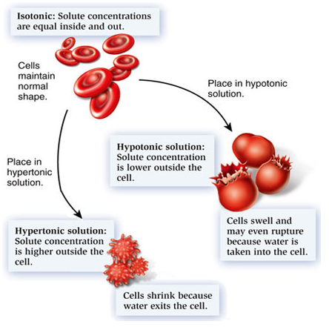
Isotonic solution | Hypertonic solution | Hypotonic solution
- There is equal water potential inside and outside of the cell.  - Therefore, normal movement of water inside and out.  - Cell maintains its shape. | - There is low water potential outside of the cell, and high water potential inside the cytoplasm.  - Water molecules leaves by osmosis.  - The cell shrinks in size (crenated). | - There is high water potential outside the cell, and low water potential in the cytoplasm.  - Water molecules enter by osmosis.  - Cell expands and bursts.
- When the cell shrinks and little spikes appear on the cell surface membrane, this process is called crenation.
- An animal cell will become dehydrated and eventually die when placed in a solution of low water potential.
Q. Why is turgor important in plants?
- Turgor enables plant to remain firm and erect (due to turgor pressure within their cells).
- When there is high evaporation of water from the cells, they lose their turgidity and the plant wilts.
- Plasmolysis causes tissues to become limp or flaccid. Cells will be killed if they remain plasmolysed for too long.

