Name:_________________________________________ Block:____ Date:____________________

CALCULATING SURFACE AREA TO VOLUME RATIOS

First of all, the SURFACE AREA (abbreviation = SA) is the area of material that it would
take to completely cover an object (for example, the amount of wrapping paper it would |  |  | 3 cm
take to precisely wrap an expensive gift to your biology teacher☺).
 |  |  | 3
For a simple cube shape, surface area is simply the length of one side times the height of
one side times the number of sides (all cubes have, incidentally, 6 sides). The formula can
be written like this.
Surface Area = Length x Height x 6
For example, a cube that was 3 cm on each side would have a surface area of:
SA = 3 cm x 3 cm x 6 | = | 54 cm²
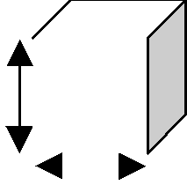
Notice that the units are "square" units.

- VOLUME (V) is the amount of space inside an object.

- Volume for a simple cube is equal to the length times the height times the depth of an
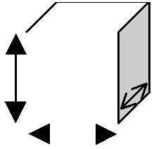
object. | 3 cm
V = L x H x D
 | 3
For the above example of a 3 cm cube, the volume would be: |  |  |  |  | 3
V = 3 cm x 3 cm x 3 cm = 27 cm³
Notice that the units are "CUBIC" units.
The surface area to volume ratio (SA:V) is the proportion of area of material covering an object to amount of
material within the object. i.e. it is a measure of how much covers the object for each unit of interior volume. For the above example:

SA:V 54:27
(this ratio can be reduced to smaller numbers similar to the way that fractions can be reduced. It is customary to reduce SA:V ratios so that V is equal to 1. This can be done by dividing the SA by V and V by V as below)
54/27: 27/27 2:1
- The surface area to volume ratio for the above cube is equal to 2:1. That is, for every 2 units of surface area covering the outside of the cube, there is 1 unit of volume in the inside of the cube. If this cube were a cell, we could further say that there are 2 units of cell membrane for every unit volume of cytoplasm in its interior.

Now you try: Key is on other side -- DO NOT LOOK until you've solved these problems on your own.

- For the four cubes below, measure (in cm) each with a ruler, and calculate the surface area, the volume, and the surface area to volume ratio. Reduce the SA:V ratio so that it the "V" is = 1.

Cube A
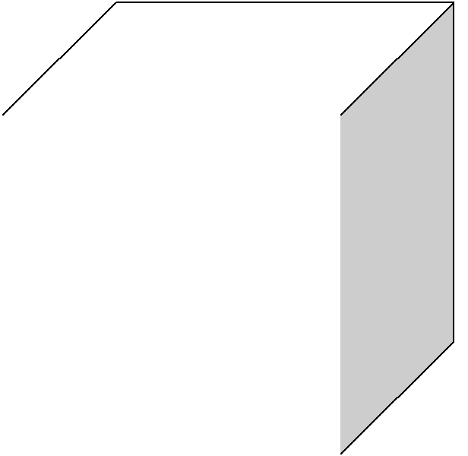
Surface Area

Volume

S:V ratio (reduced)

Cube B
Surface Area
Volume
S:V ratio (reduced) |  |  |  |  |  |  |  |  |  |  |  |  | D
Cube C
Surface Area
Volume |  |  |  |  |  |  |  |  |  | C
S:V ratio (reduced) |  |  |  |  |  | B
Cube D |  |  | A
Surface Area
Volume
S:V ratio (reduced)
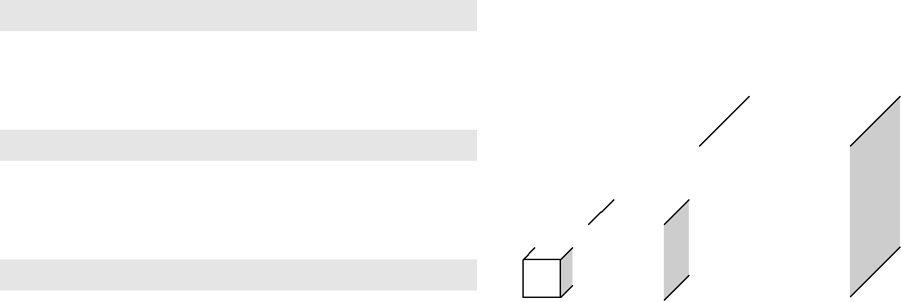
- What trend do you notice as the size of the cells increases?

- Why is this important to living cells?
- What can cells do about it?

Credits to: Teacherweb.com; Stephanie McKay. Page 1 of 2 [Downloaded for use in: http://friedbiochem.weebly.com. /TcNMA]

KEY: You're not sneaking a peek before attempting the questions, are you?

Cube A
Surface Area | 1.5 cm²
Volume | 0.125 cm³
S:V ratio (reduced) | 12:1
Cube B
Surface Area | 6 cm²
Volume | 1 cm³
S:V ratio (reduced) | 6:1
Cube C
Surface Area | 24 cm²
Volume | 8 cm³
S:V ratio (reduced) | 3:1
Cube D
Surface Area | 96 cm²
Volume | 64 cm³
S:V ratio (reduced) | 1.5:1

3. What can cells do about it?

Cells can:

- What trend do you notice as the size of the cells increases?

The surface area to volume ratio decreases as cell size increases (e.g. as cell size doubles, SA:V ratio is reduced 50%)

- Why is this important to living cells?

Living cells can only get materials in (like glucose and oxygen) through the cell membrane, and can only get waste products out through the cell membrane. As SA:V ratio decreases, it means that every unit of volume of cytoplasm is "serviced" by less and less surface area. If the cell is actively metabolizing, it may not be able to get in enough nutrients or get rid of its wastes. Furthermore, as most things get around in cell via diffusion (a free albeit slow process), as a cell gets larger, it may not be able to get materials from one end of a cell to the next by diffusion quick enough to sustain its chemical reactions.

- divide

- slow down metabolism
- change shape to increase the surface area (e.g. get long and thin or flat, or develop many folds in the cell membrane to increase SA and therefore SA:V ratio.
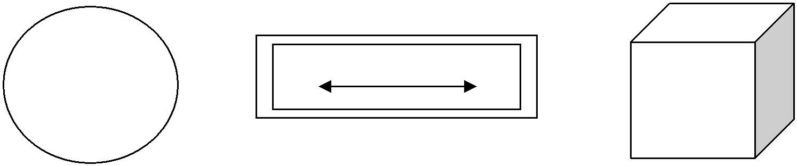

Poor (i.e. Low) SA:V ratios
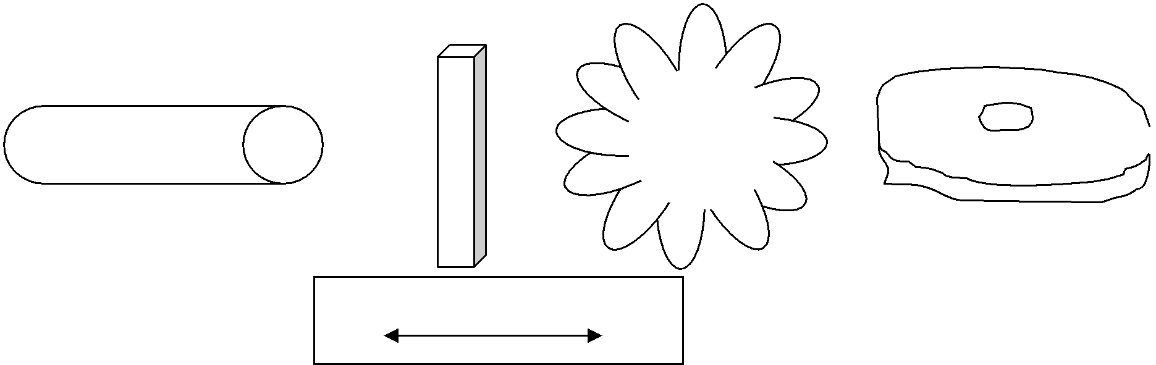

Better (i.e. High) SA:V ratios

Credits to: Teacherweb.com; Stephanie McKay. Page 2 of 2 [Downloaded for use in: http://friedbiochem.weebly.com. /TcNMA]

